Project Design Phase-Il

Data Flow Diagram &User Stories

|  |  |
| --- | --- |
| Date | 03ctober 2022 |
| Team ID | PNT2022TMID52096 |
| Project Name | Intelligent Vehicle Damage Assessment and Cost Estimator for Insurance Companies |
| Maximum Marks | 4 Marks |

Data Flow Diagrams:

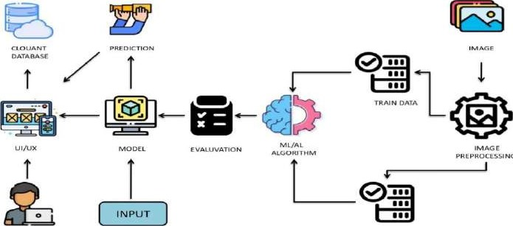

ROCESSING

u

SER

T

EST

DATA

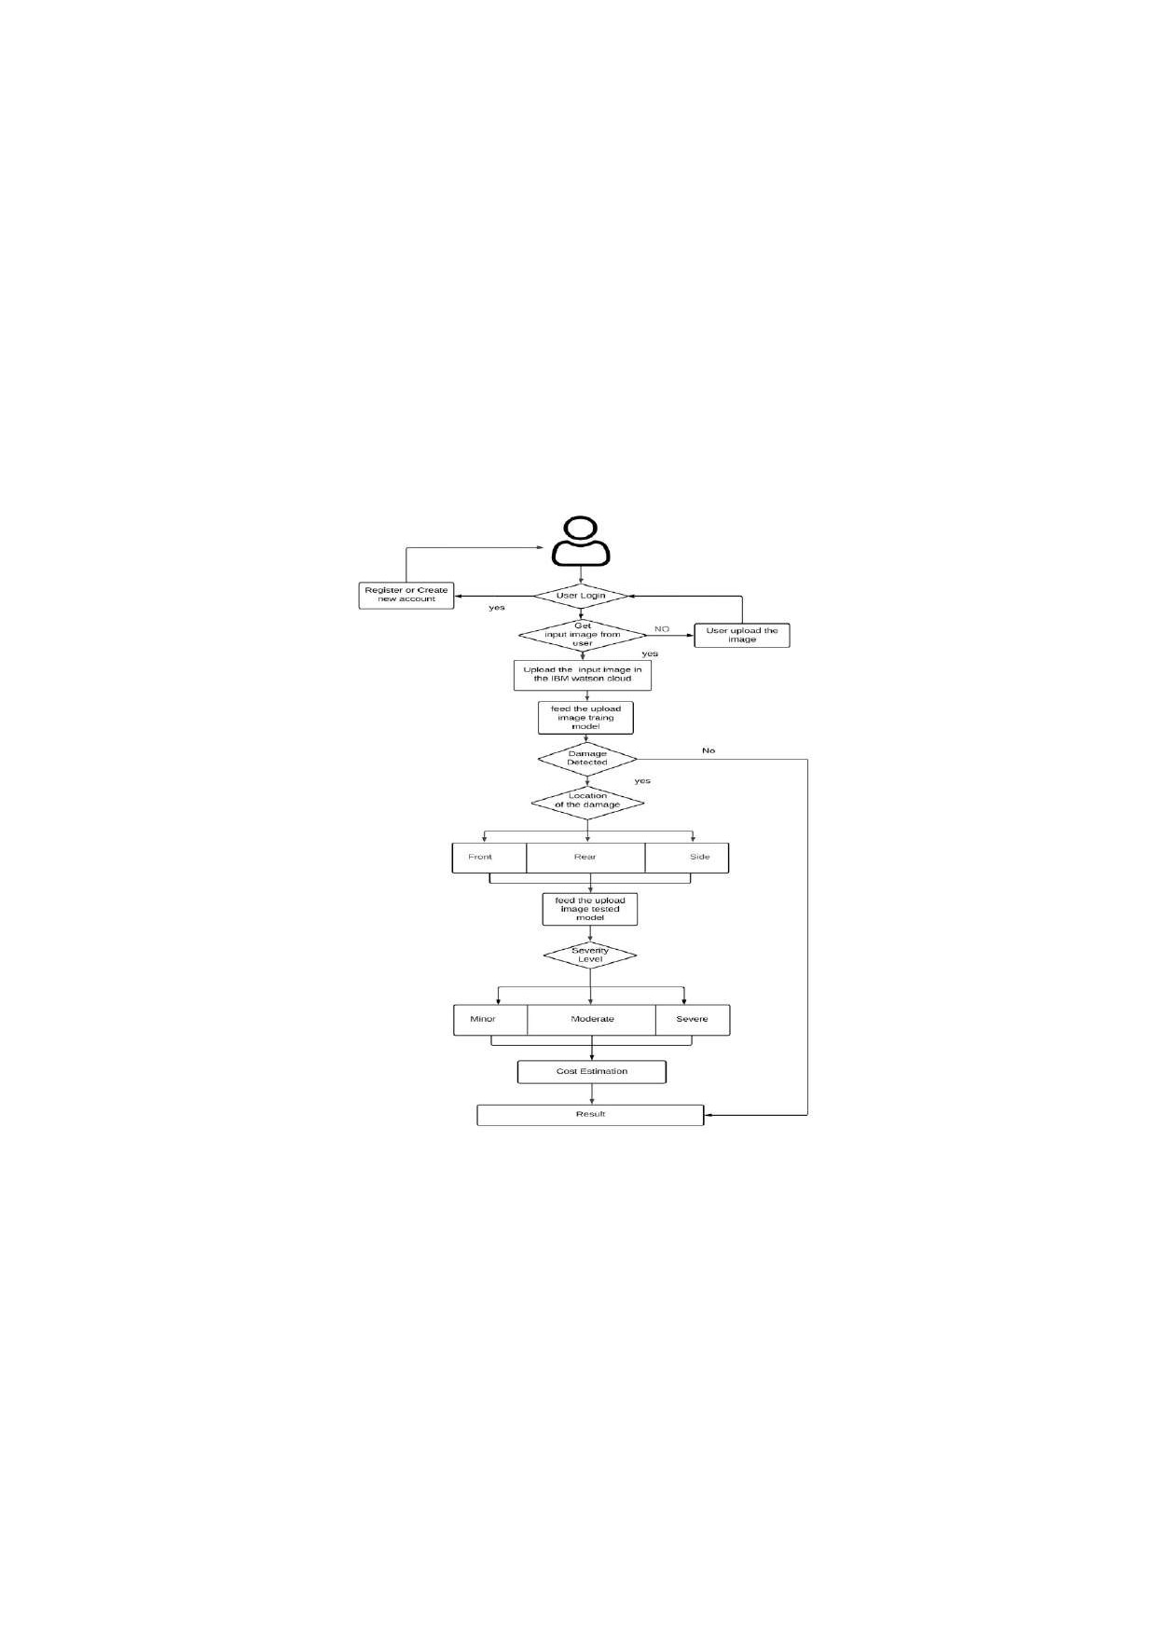

User Stories

Use the below template to list all the user stories for the product.

|  |  |  |  |  |  |  |
| --- | --- | --- | --- | --- | --- | --- |
| User Type | Functional  Requirement | User Story Number | User Story / Task | Acceptance criteria | Priority | Release |
| Customer  (Mobile user) | Registration | USN-I | As a user, can register for the application by entering my email, password, and confirming m assword | can access my account dashboard by entering valid credentails | High | Sprint-I |
| Customer  Details | Login | USN-2 | As a user, WII receive confirmation email once I have registered for the application | can receive confirmation email & click confirm | High | Sprint-I |
| Customer Uses | Dashboard | USN-3 | As a user. can register for the applicatlon through Face-bx.k | can & access the dashboard with Facebook L in | Low | Sp rint4 |
| Customer Options | Details about insurance companies | USN-4 | As a user, can register for the application through Gmail | can register & access the dashboard with Facebook Gmail | Medium | Sp rint-l |
| Customer usage | Login | USN-5 | As a user, can log into the application by entering email & password | can log in and view my dashboard at my demand on any time | High | Sprint-I |
| Customer needs to do | Dashboard | USN-6 | As a user I must capture images of my vehicle and upload it into the web portal | can capture the entire vehicle and u load | High | Sprint-2 |
| Customer (W eb user) | Details about estimated cost based on damage | USN-7 | As a user must receive a detailed report Of the damages present in the vehicle and the cost estimated | can get the estimated insurance cost | High | Sprint-3 |
| Customer Care Executive | Details about  Estimated cost  Based on damage | usu | As a user, I need to get support from developers in case of queries and failure of service rovided | can have smooth user experiences and all the issues raised is sorted | Medium | Sprint-4 |
| Adm inistrator | Details about  Estimated cost  Based on damage | USN-8 | We need to satisfy the customer needs in an efficient way and make sure any sort of errors are fixed | can finish the work without any problems | High | Sprint-4 |